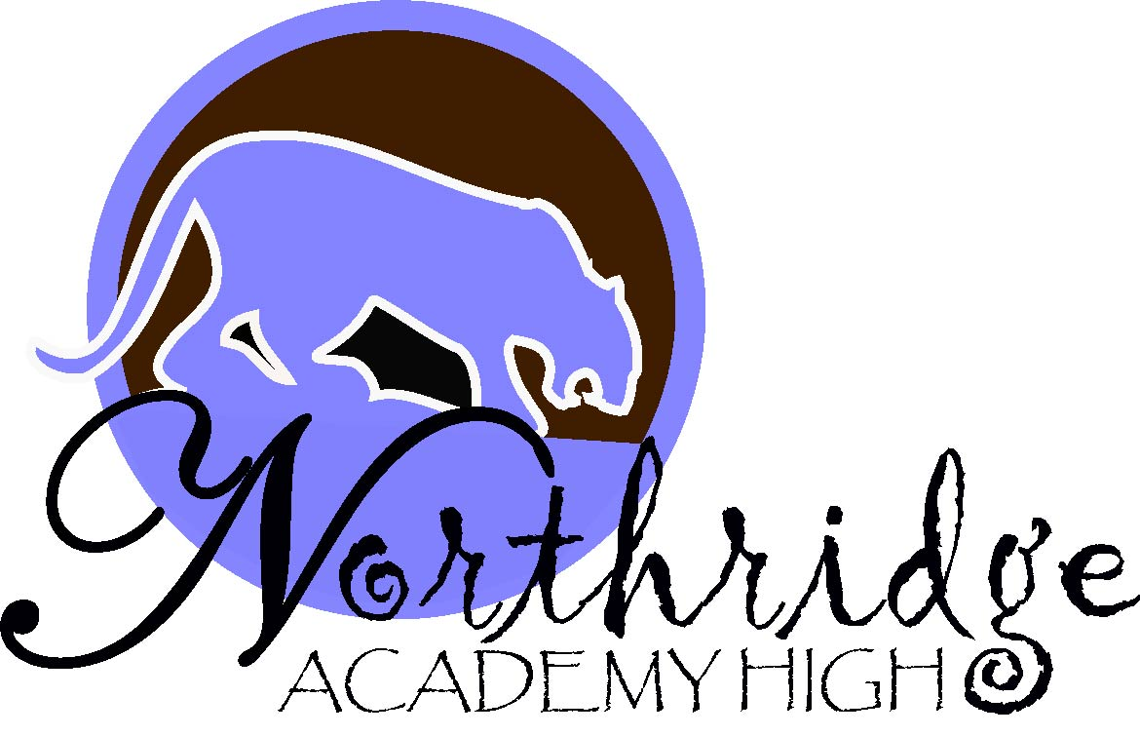
September 8, 2021
Megan Riley, Interim
Superintendent of Schools
Los Angeles Unified School District

Joseph Nacorda
Local District Northwest
Arts, Media & Communication ♦ Health & Human Development ♦ Careers in Education | Superintendent  Dr. Donna Gilliland  Community of Schools Administrator  Local District Northwest  Nidia Castro  Principal
Web: www.northridgeacademyhs.org
9601 Zelzah Avenue, Northridge, California 91325
Phone: (818) 700-2222 Fax: (818) 718-2239

Hello Puma Families,
I hope that this letter finds you safe and healthy. Although we are not ready to have in-person parent meeting for large groups, we are very excited that school is in session and that we will have the opportunity to virtually hold our Back to School Night on Thursday, September 9, 2021 from 5:00-7:00PM. The event will be facilitated via zoom. Teachers will be providing your child with the zoom link or meeting ID. Please write the links on the schedule before so you have them all in one place.

This evening is for teachers to present an overview of their courses and to go over class expectations with parents and guardians. It is not the occasion for individual parent conferences.
Parents who wish to schedule a meeting with their child’s teacher to discuss individual student progress should send a by emailing the teacher.

Period | Time | Zoom Link
1 | 5:00-5:14PM
2 | 5:15-5:30PM
3 | 5:32-5:46PM
ADV | 5:48-6:02PM
BREAK | 6:02-6:12PM
4 | 6:14-6:28PM
5 | 6:30-6:44PM
6 | 6:46-7:00PM

Thank you for your patience during these unprecedented times.

Sincerely,

Nidia E. Castro
Principal

